toString ( )

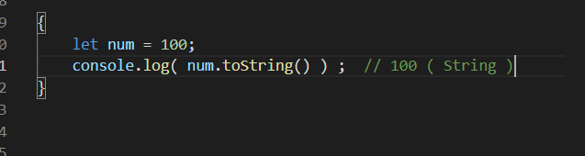

converts Number data type to string

toFixed ( n )

here n length **after** the decimal point

toPrecision( x )

here x total length

Also in both cases the number is rounded off and returned as string to us

